South Metropolitan TAFE

Web Programming

documentation

PROJECT – Daniel Hee (P466436)

Table of Contents

Address what develop and run environment are used 2

To set up a server side environment and database 2

Identify any ambiguity in the specifications and requirements and clarify them before designing the application 3

Design of the application 4

Website navigation hierarchy 5

Database Design 6

CSS Design 7

Header Design 7

Developing the application 8

Show All Tab 8

Search Tab 9

Movie searched based on Genre, Rating and Year 9

Movie searched based on title and genre 10

No movie is found 10

# Address what develop and run environment are used

To develop and run environment, you will be needing these software which are any internet browser so you can test your code, XAMPP – this will act as a server and database and NotePad++ - this will be used to develop.

## To set up a server side environment and database

Click start for both Apache and MySQL

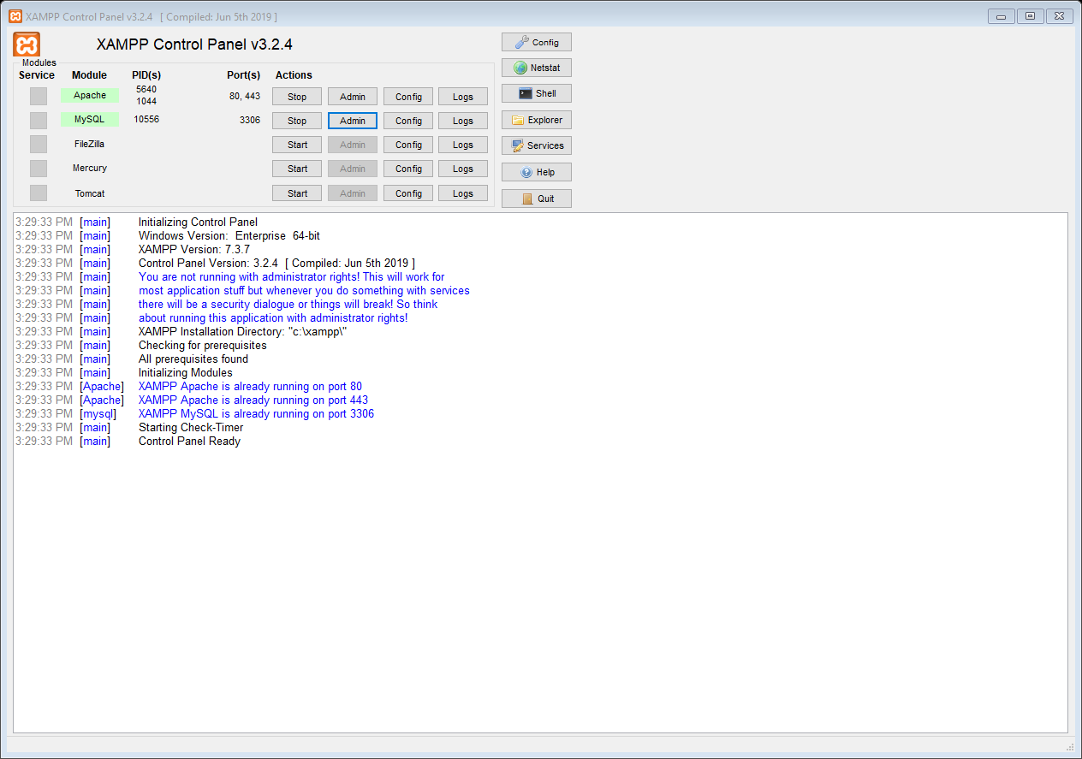

When you click the Admin button for the Apache server, it will lead you to the main admin page on the browser if everything has been set up correctly.

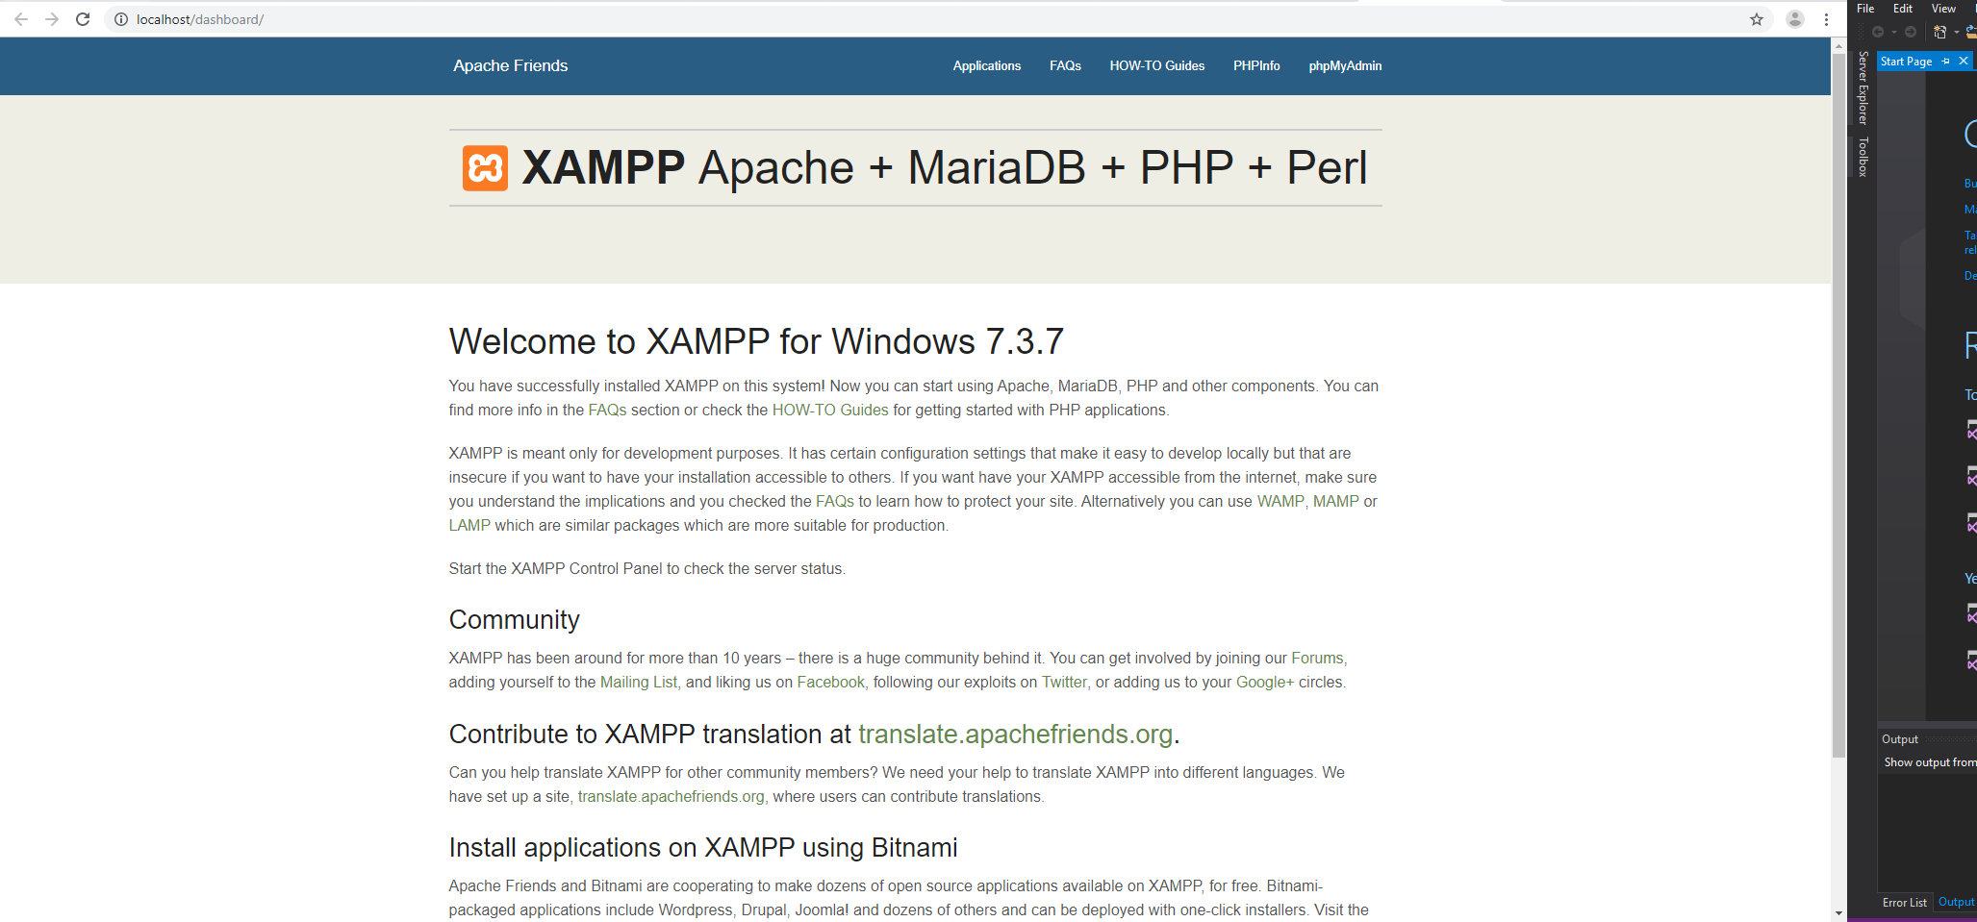

When you click the Admin button for theMySQL server, it will lead you to <http://localhost/phpmyadmin/> on the browser and you can add information into server.

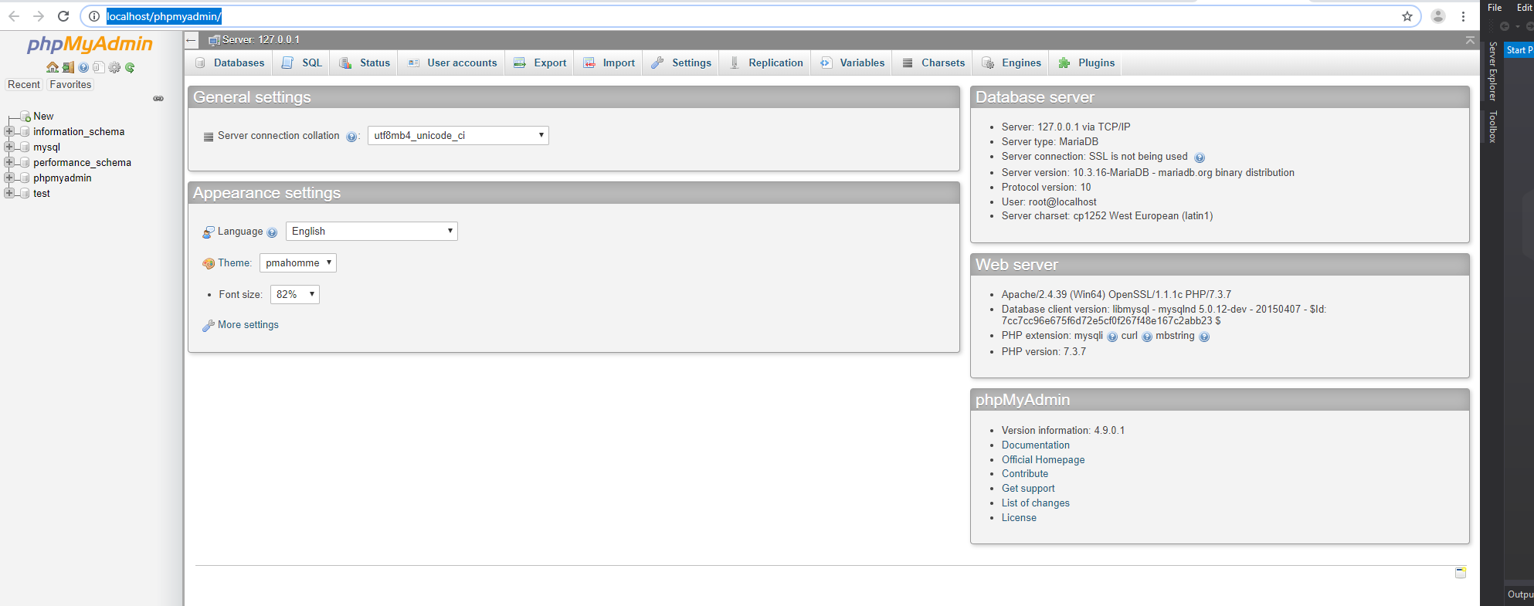

## Identify any ambiguity in the specifications and requirements and clarify them before designing the application

* Unable to import into database without converting the Excel File into CSV format
* Unable to run the application with random IP Address

# Design of the application



This is how the website looks like. I used an image related to movie as the website’s background. This website has the functionality to search by the title, genre, rating and year of the movie, it can display all movies information and display the top 10 most frequently searched movies.

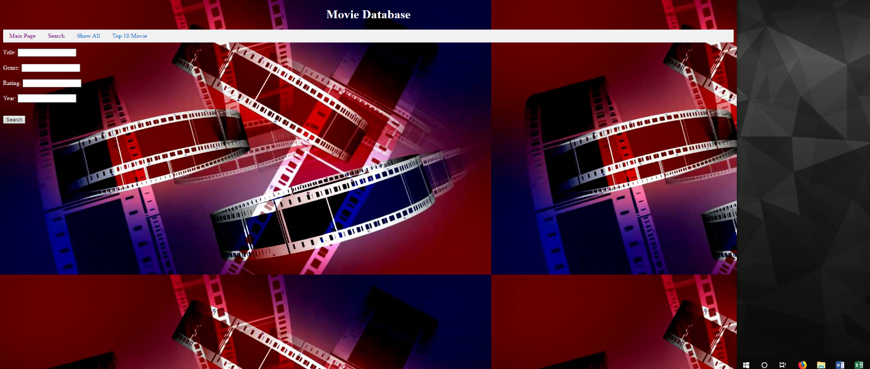

This is how the search page looks like.

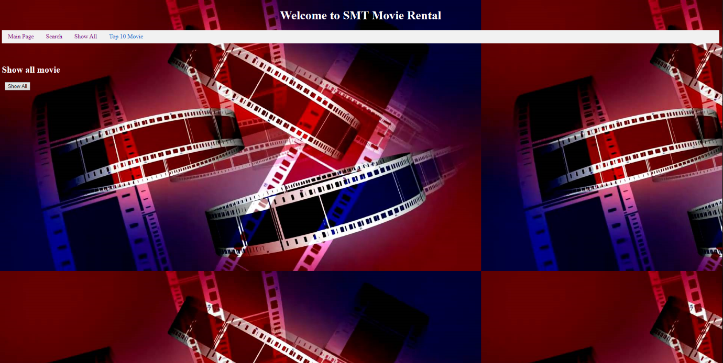

This is how the show page looks like. This button has the functionality to display all movie information that are stored in the database.

Website navigation hierarchy

Database Design

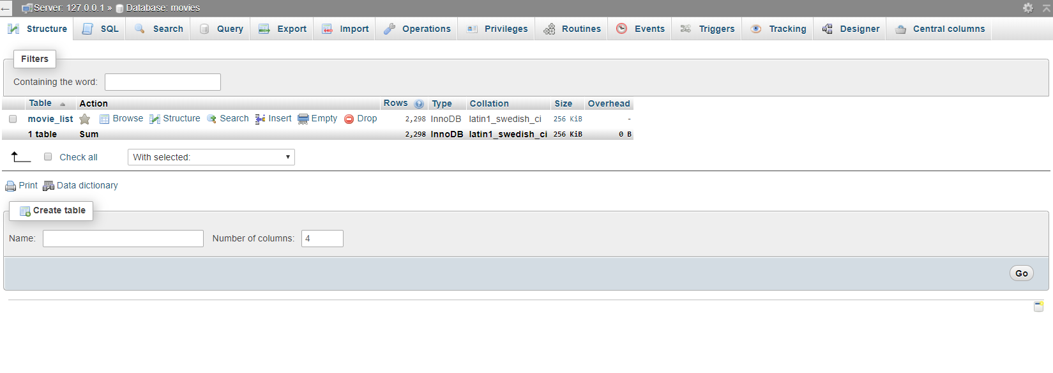

This is how the database looks like. You will be able to add tables with information that are related to the database.

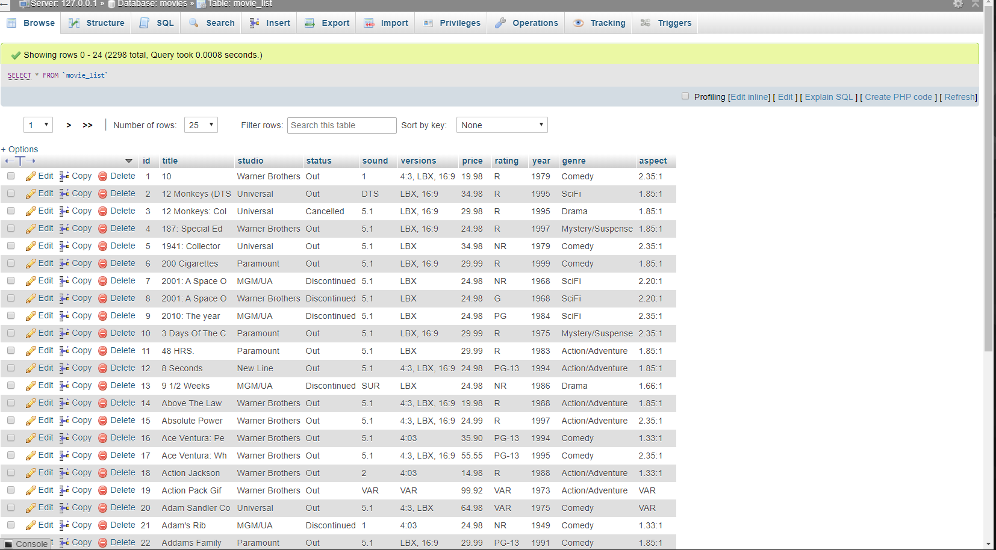

I created a table called movie_list. This is how the table looks like. It have information for the title, studio, status, sound, versions, price, rating, year, genre and aspect of the movies.

Table below shows the datatype for each option.

|  |  |
| --- | --- |
| ID | INTEGER (5) |
| Title | VARCHAR(15) |
| Studio | VARCHAR(20) |
| Status | VARCHAR(15) |
| Sound | VARCHAR(5) |
| Version | VARCHAR(30) |
| Price | DECIMAL(6,2) |
| Rating | VARCHAR(10) |
| Year | INTEGER(4) |
| Genre | VARCHAR(20) |
| Aspect | VARCHAR(10) |

### CSS Design

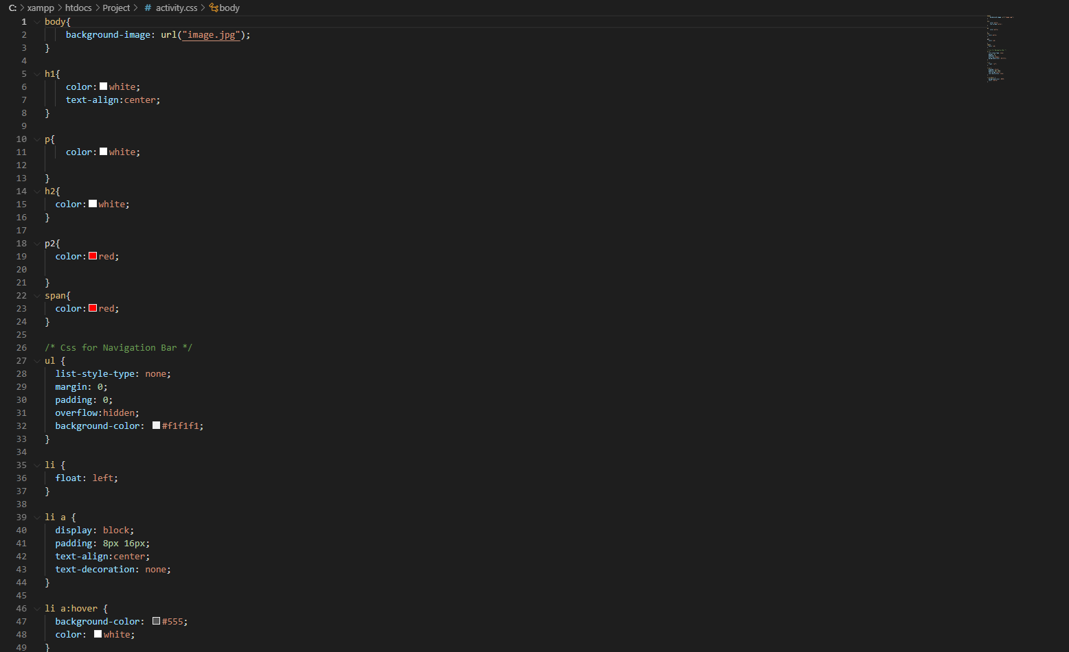

CSS stands for Cascading Style Sheet which is a stylesheet language used to describe the presentation of a document written in HTML or XML. This is a brief code for my CSS of the web.

### Header Design

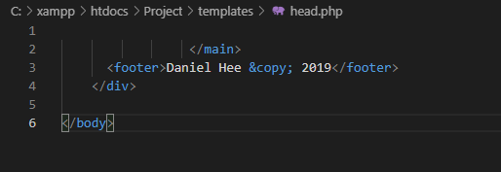

This is the code for my header.

# Developing the application

## Show All Tab



There is a button under the tab “Show All” which will display all the movies that are stored in the database.

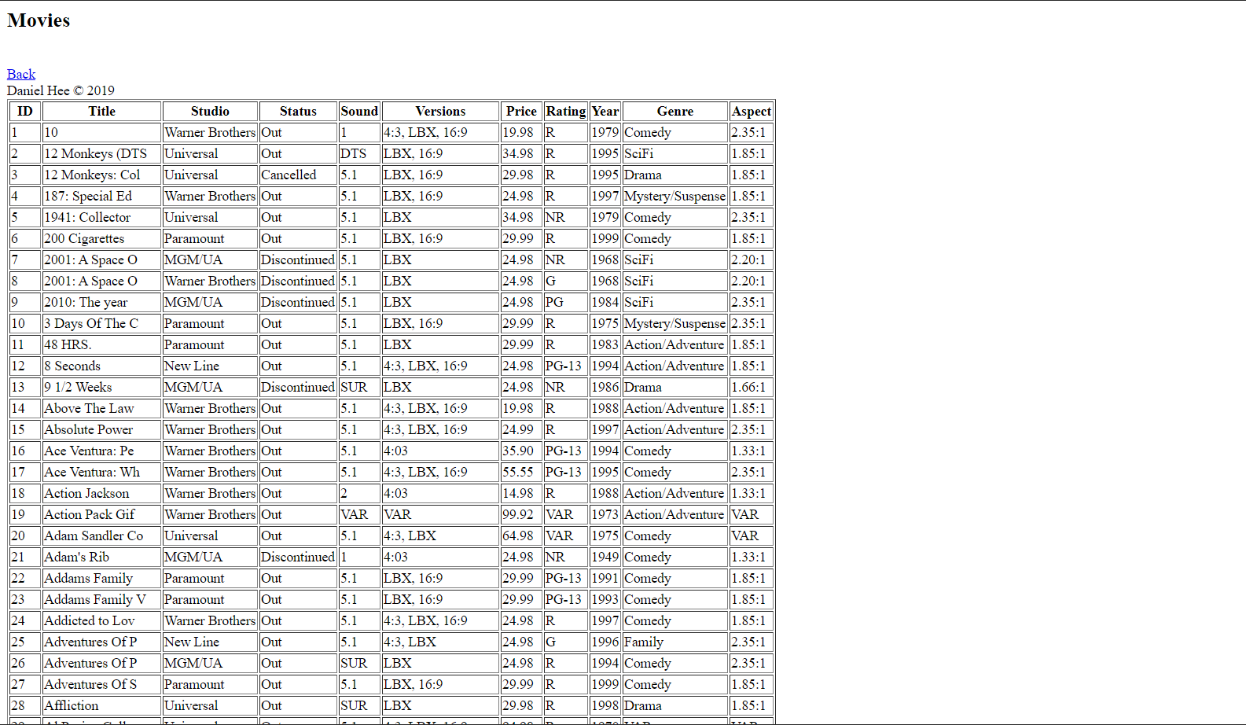

Here’s the result after clicking the button. All information regarding movie that are stored will be displayed.

## Search Tab

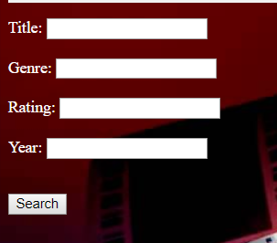

Insert information that you have inside the text field provided and click on the button. Then it will display the full details of each movie found but if no movie is found, the application will display **No Movie Found.**

### Movie searched based on Genre, Rating and Year

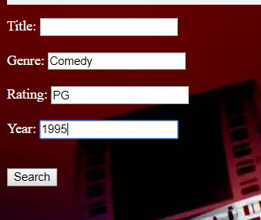

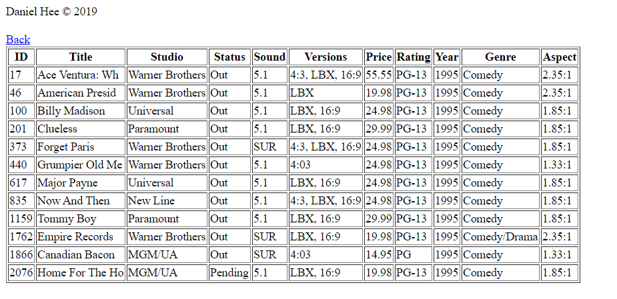

When there’s movie related to it, it will display the full details of it.

### Movie searched based on title and genre

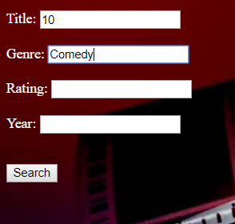

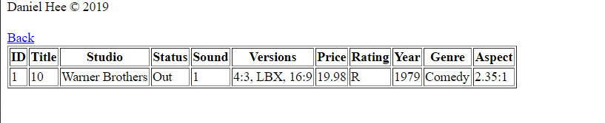

When there’s movie related to it, it will display the full details of it.

### No movie is found

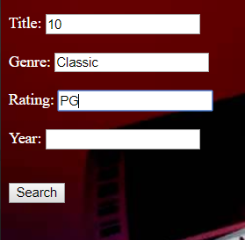



## Top 10 Movies Searched Tab



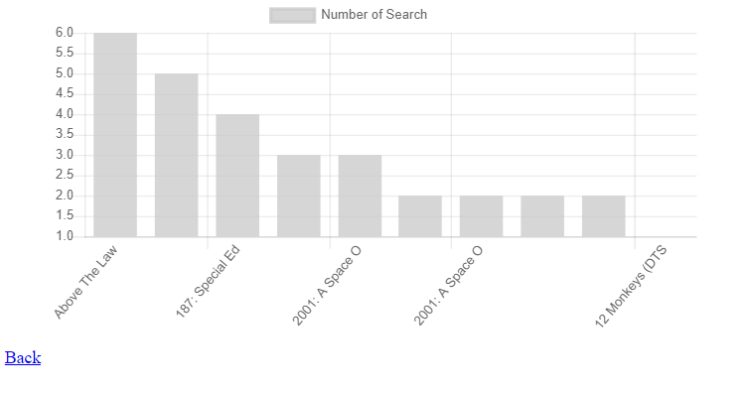

When the button “Generate Chart” is pressed, it will generate a bar graph based on the number of times you’ve searched.